TEACHER KEY

Who Bears a Per-Unit Tax?

Teacher Answer Key
TEACHER KEY - DO NOT DISTRIBUTE AS THE STUDENT HANDOUT
AP Microeconomics | 40-minute lesson | New original free-sample lesson candidate | Private review only
Teacher: ____________________ Date: ____________________
This is an original companion lesson, not an excerpt from a paid product. All bottle-market data are illustrative and simulated. They are not observed market evidence. The lesson assumes a competitive market, unchanged linear underlying demand and supply, a fully collected $4 per-bottle tax, no avoidance, no externalities and no other policy change. Quantities are bottles per day; prices are dollars per bottle.
Use this file only after students have attempted the corresponding numbered tasks. The separate student source contains the prompts and answer spaces. This key solves tasks 1 through 12, including subprompts. Optional checks below support the teacher; they are not extra required student tasks within the 40 minutes. Designed timing has not been classroom piloted. Students need prior practice with supply/demand graphs, surplus, and rectangle/triangle areas; use more time or a prerequisite lesson if those foundations are insecure.

At a glance
Result | Before tax | After tax
Bottles traded per day | 12 | 8
Buyer price, dollars per bottle | $6 | $8
Seller receipt after any tax payment, dollars per bottle | $6 | $4
Tax wedge, dollars per bottle | $0 | $4
Buyer burden: $2 per traded bottle, $16 per day, 50% of the tax. Seller burden: $2 per traded bottle, $16 per day, 50% of the tax. Government revenue: $32 per day. Deadweight loss: $8 per day. Exit answers: 9 B; 10 D; 11 A; 12 C.

1. Initial prediction and later revision
Ungraded. Accept any initial prediction that gives a reason. A student may initially predict that sellers bear all the tax because they remit it, that buyers pay it through a higher price, or that the burden is shared. The purpose is to make the student's thinking visible before calculation, not to award a point for guessing correctly.
After task 7, ask students to revisit the prediction using the actual prices. A sound revision says: sellers remit the $4, but the buyer price rises from $6 to $8 and the seller's retained price falls from $6 to $4. Each side therefore bears $2 per traded bottle in this market.
Teacher check: Look for a price-based explanation in the revision. A tax remittance rule identifies who sends money to government; it does not by itself identify the economic burden.

2. Original demand, supply and equilibrium
The horizontal axis is Quantity of reusable bottles, bottles per day. The vertical axis is Price, dollars per bottle. Use the supplied scales, from 0 to 24 bottles per day and from $0 to $16 per bottle.
- Demand D connects (0,12) and (24,0). It passes through all supplied demand-table points.
- Original supply S connects (0,0) and (24,12). It passes through all supplied supply-table points.
- The original equilibrium E0 is (12,6). Label Q0 = 12 bottles/day and P0 = $6/bottle.
At Q = 12, the demand price and supply price are both $6. This is the common price and quantity at which quantity demanded equals quantity supplied. An algebraic cross-check is 12 - Q/2 = Q/2, giving Q = 12 and P = 6.
Teacher checks: Axes have quantities and units; curves have D and S labels; E0 lies on both curves; horizontal and vertical guides, if used, land at Q0 = 12 and P0 = 6. The demand intercept of $12 is not the equilibrium price.

3. Seller asking-price-with-tax column
At each quantity, add the $4 tax to the original supply price. These are the prices buyers would have to pay for sellers to retain the original supply price after remitting the tax.
Q, bottles/day | Demand price, $/bottle | Original supply price, $/bottle | Seller asking price with tax, $/bottle
0 | 12 | 0 | 4
4 | 10 | 2 | 6
8 | 8 | 4 | 8
12 | 6 | 6 | 10
16 | 4 | 8 | 12
20 | 2 | 10 | 14
24 | 0 | 12 | 16
The taxed supply schedule, expressed as the price buyers pay, is P = Q/2 + 4. It is $4 above original S at every quantity. Underlying production costs have not changed; the tax creates the wedge.
Common error: Adding $4 to demand or multiplying each supply price by 4. Prompt: "What price must a seller charge to keep the same amount after sending $4 per bottle to government?"

4. Taxed equilibrium, both prices and the wedge
- S + tax connects (0,4) and (24,16).
- Its intersection with D is Etax = (8,8). Thus Qt = 8 bottles/day and Pb = $8/bottle.
- At the same quantity Q = 8, original S gives Ps = $4/bottle, at (8,4).
- The vertical wedge joins (8,4) to (8,8). Its height is Pb - Ps = 8 - 4 = $4/bottle.
An algebraic check is 12 - Q/2 = Q/2 + 4, so Q = 8. Demand then gives Pb = 8 and original S gives Ps = 4. Sellers collect $8 from the buyer, remit $4 and keep $4 per bottle.
Teacher checks: The two prices are measured at the same Qt. Pb lies on D and S + tax; Ps lies on original S. The wedge is vertical, not horizontal. The original E0 remains marked for comparison.
Common errors: Keeping Q = 12 after the tax; labeling both after-tax prices $8; locating Ps on S + tax. Prompt: "At the new quantity, how much does the buyer pay and how much does the seller keep?"
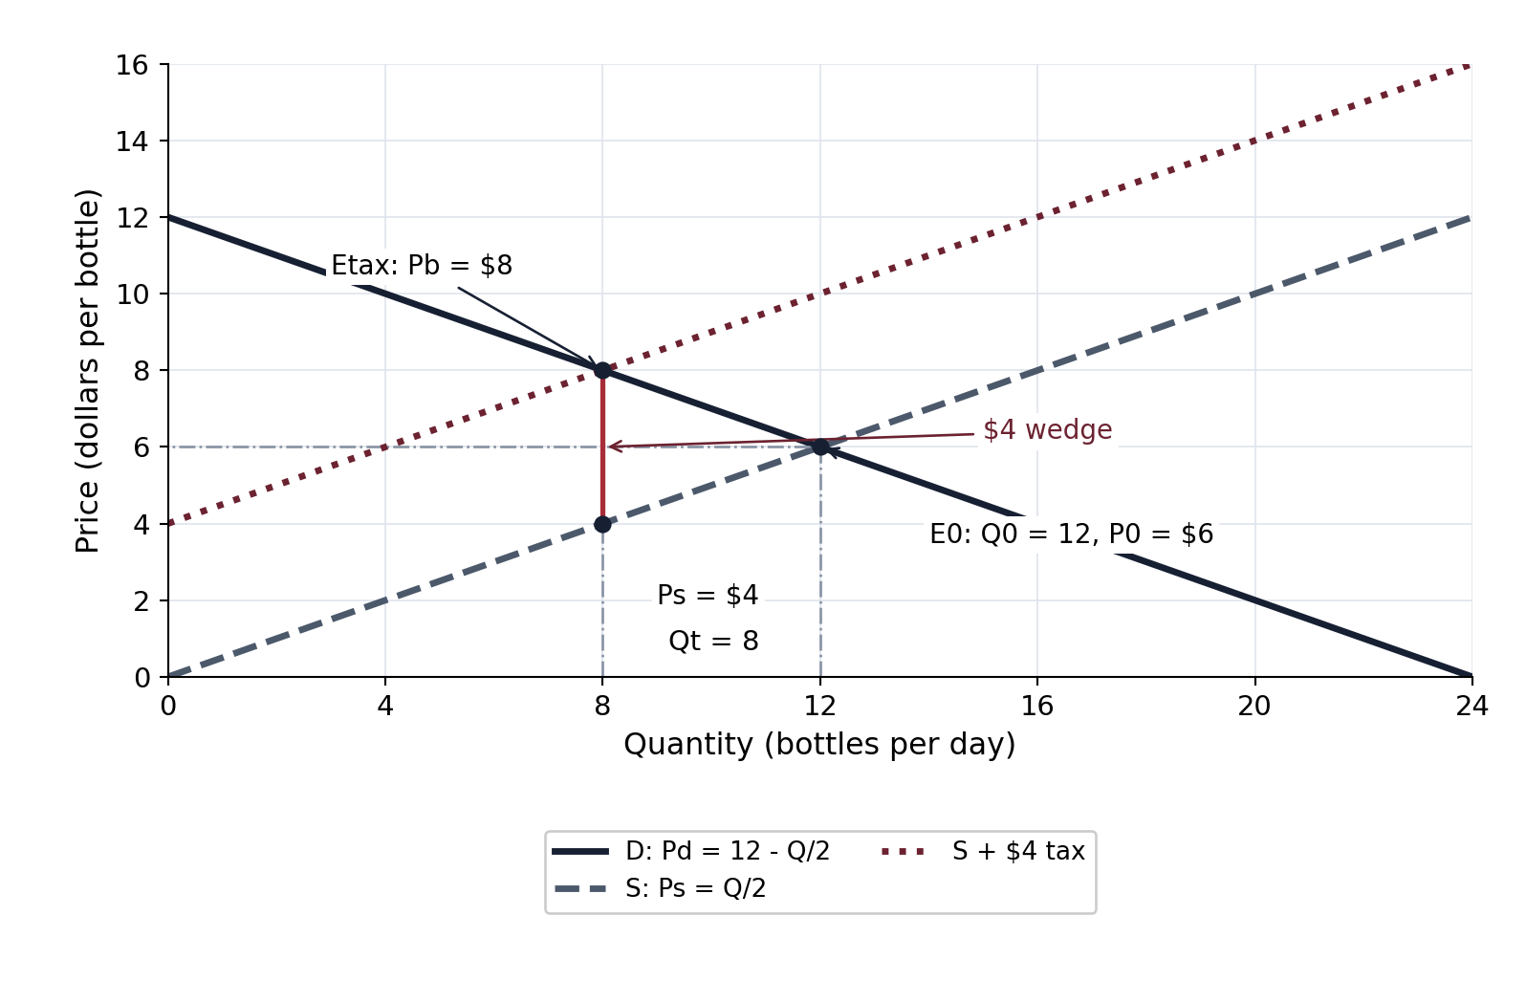

5. Before/after accounting and economic incidence
The first three rows answer the student accounting table. The last three rows are optional instructor cash checks, not extra required student calculations.
Accounting item | Before tax | After tax
Quantity, bottles/day | 12 | 8
Buyer price, $/bottle | 6 | 8
Seller retained receipt, $/bottle | 6 | 4
Buyers' spending, dollars/day | 6 × 12 = 72 | 8 × 8 = 64
Sellers' retained receipts, dollars/day | 6 × 12 = 72 | 4 × 8 = 32
Government tax revenue, dollars/day | 0 | 4 × 8 = 32
Buyer incidence: Pb - P0 = 8 - 6 = $2/bottle. On the 8 bottles still traded, 2 × 8 = $16/day. Share of the tax: 2/4 × 100 = 50%.
Seller incidence: P0 - Ps = 6 - 4 = $2/bottle. On the 8 bottles still traded, 2 × 8 = $16/day. Share of the tax: 2/4 × 100 = 50%.
Checks: $2 + $2 = $4/bottle; $16 + $16 = $32/day; 50% + 50% = 100%. After-tax buyers' spending equals seller retained receipts plus government revenue: $64 = $32 + $32.
Teacher distinction: The $16 figures measure each side's tax burden on the bottles that still trade. They are not each side's entire welfare loss. Also, retained receipts are not profit or producer surplus. Buyers' total spending falls here because fewer bottles trade; that does not mean buyers benefit from the tax.
Common errors: Multiplying the per-bottle burden by the old quantity of 12; calling $4 the buyer's burden; reporting 2% rather than 50%. Prompt: "Compared with the old $6 price, what changed for each side, and how many bottles still trade?"

6. Government revenue, lost trades and deadweight loss
Revenue rectangle: vertices (0,4), (8,4), (8,8), (0,8). Height = $4/bottle; width = 8 bottles/day. Government revenue is 4 × 8 = $32/day.
Deadweight-loss triangle: vertices (8,4), (8,8), (12,6). Vertical base = $4/bottle; horizontal height = 12 - 8 = 4 bottles/day. Deadweight loss is 1/2 × 4 × 4 = $8/day.
Quantity falls because the tax separates what the buyer pays from what the seller keeps. The additional transactions between Qt = 8 and Q0 = 12 would have generated gains from trade without the tax, but their willingness-to-pay minus supply-price gap is too small to cover the $4 wedge. The lost quantity is 4 bottles/day, represented by the quantity interval from 8 to 12. The original marginal trade at Q0 has zero net gain in the graph.
Continuous-model note: Treat these linear schedules as continuous for the graph and area calculation. "Four foregone trades" means four fewer bottles per day, not four table rows or four discrete bids valued at integer endpoints. Do not sum the endpoint values at Q = 9, 10, 11 and 12 to replace the stipulated triangle area.
Why the rectangle and triangle have different economic meanings: Government revenue is transferred from market participants to government; it is not the deadweight loss in this no-externality model. The triangle measures surplus lost on the transactions that no longer occur.
Optional teacher welfare check, not another timed student task:
Surplus, dollars/day | Before tax | After tax
Consumer surplus | 1/2 × 12 × (12 - 6) = 36 | 1/2 × 8 × (12 - 8) = 16
Producer surplus | 1/2 × 12 × (6 - 0) = 36 | 1/2 × 8 × (4 - 0) = 16
Government revenue | 0 | 32
Total surplus, including government revenue | 72 | 64
Total surplus falls by 72 - 64 = $8/day, agreeing with the triangle. Consumer and producer surplus each fall by $20: $16 from each side is part of the tax transfer on continuing trades, and $4 from each side is lost surplus on foregone trades. Do not count the transfer twice or confuse it with deadweight loss.
Common errors: Using 12 in tax revenue; shading all revenue as deadweight loss; drawing the loss triangle to the left of Qt. Prompts: "Which bottles are actually taxed?" and "Which transactions disappear?"
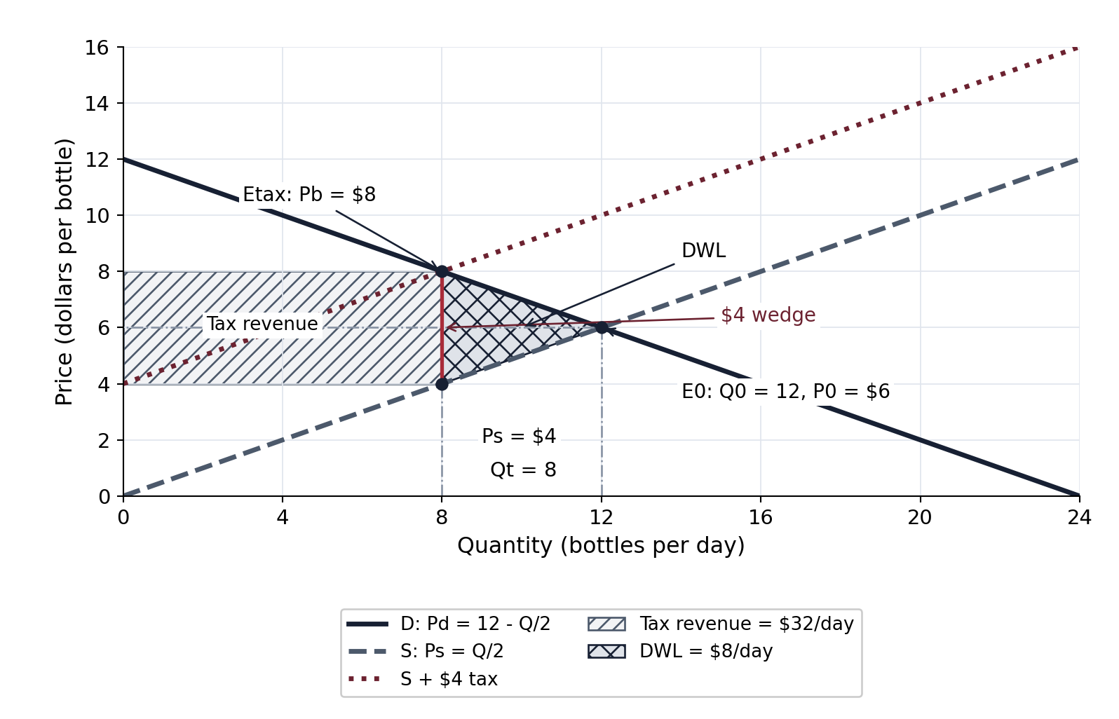

7. Legal remittance versus economic burden
Claim evaluation: The claim is false in this market. Sellers send the $4 tax to government, but buyers pay $8 rather than $6 and sellers retain $4 rather than $6. Buyers bear $2 per bottle and sellers bear $2 per bottle.
If buyers remit instead: Under the stipulated competitive model, collecting the same $4 per-bottle tax from buyers would leave economic incidence unchanged. The same wedge must satisfy Pb - Ps = 4, together with Pb = 12 - Q/2 and Ps = Q/2. This again gives Q = 8, Pb = 8 and Ps = 4.
For a seller-price graph, demand net of the buyer-paid tax would be Ps = 8 - Q/2; it intersects original S at (8,4). Buyers then pay the $4 tax in addition to the seller's $4 receipt, for a total $8 per bottle. This is an optional algebraic verification, not a required extra graph.
Acceptable response: A clear verbal explanation of the same $4 wedge and the same underlying demand and supply is sufficient. Students need not write all equations.
Limit: This invariance result relies on the exercise's unchanged curves and fully collected tax with no avoidance or other policy change. Do not extend it to claims that actual administrative rules never matter.

8. Different relative elasticities
In the other market, buyers tend to bear the larger per-unit share when demand is less price-responsive in percentage terms than supply at the relevant equilibrium. Buyers change quantity relatively little in response to a price change; sellers are relatively better able to change quantity. More of the wedge is reflected in a higher buyer price.
Acceptable wording: "Demand is relatively more inelastic than supply, so buyers bear more of the tax." Add a reason about relative responsiveness for the full diagnostic point. Do not infer a particular dollar or percentage share without that market's data.
Percentage-response note: Price elasticity compares a percentage quantity change with a percentage price change. A raw slope depends on axis units and does not by itself provide a universal elasticity measure. On a linear demand curve, slope is constant while elasticity changes along the curve. The equal $2 burdens in this bottle example are derived from its original data; they are not a rule for all taxes.
Common error: Saying "the steeper line always bears more" without considering units, the point measured and percentage responsiveness. Prompt: "Are you comparing raw units or percentage changes?"

9. Exit multiple choice: quantity
B. 8 bottles/day. Demand and taxed supply meet at Q = 8. A uses the tax amount as quantity; C keeps the old untaxed quantity; D uses a price/table value instead of the new quantity.

10. Exit multiple choice: seller receipt
D. $4/bottle. Sellers receive $8 from buyers, remit $4 and retain $4. A is the buyer price; B is the old price; C would incorrectly leave sellers with no receipt.

11. Exit multiple choice: government revenue
A. $32/day. The $4 tax applies to the 8 bottles still traded: 4 × 8 = 32. B uses the old 12-bottle quantity. C is buyers' total spending, 8 × 8. D multiplies the tax by the table's 24-bottle demand intercept.

12. Exit multiple choice: larger buyer burden
C. Demand more inelastic than supply. Relative percentage responsiveness determines the usual incidence pattern. A reverses the relationship. With perfectly elastic demand in B, buyers can avoid a price increase, so the burden falls on sellers in the standard competitive model. D confuses who remits the tax with who bears it.

Original diagnostic rubric
This optional 20-point original practice rubric is not an official AP or College Board scoring guide. Task 1 is ungraded. Credit sound reasoning and correctly labeled units; use the error notes to plan feedback.
Task | Points | Evidence to check
2 | 3 | Correct axes/units; D and S; E0, Q0 and P0
3 | 1 | All seven taxed asking prices, each original S price + $4
4 | 3 | Correct S + tax; Qt/Pb; Ps and vertical wedge at the same Qt
5 | 3 | Correct before/after accounting; both burdens and totals; percentage shares
6 | 3 | Revenue region/calculation; DWL region/calculation; four fewer bottles and lost-gains explanation
7 | 2 | Price-based claim repair; remitter invariance under stated assumptions
8 | 1 | Buyers bear more, with relative percentage-responsiveness explanation
9-12 | 4 | One point per correct exit choice
Total | 20 | Task 1 remains ungraded
Diagnose propagated mistakes separately from unsupported claims. A wrong taxed quantity needs correction even if later arithmetic is internally consistent. A correct number with the wrong price label does not demonstrate the buyer/seller distinction.

Instructor pacing and references
Target duration is 40 minutes, not a tested completion-time promise. Follow the separate lesson plan's final pacing table. Required work is tasks 1-12; optional algebra and surplus checks here are teacher support, not added timed tasks.
Focused framework alignment: current AP Microeconomics Course and Exam Description, Effective Fall 2026, version 1, Topic 2.8, printed page 55 / PDF page 62 (one-based), POL-1.A and essential knowledge POL-1.A.2 through POL-1.A.6; graph skill 4.C. These are original practice prompts, not official exam items or an endorsement.
Concept checks use the official AP Microeconomics framework and OpenStax, Principles of Economics 3e, section 5.3. No source wording, examples or diagrams were copied. Source verification is recorded separately in the private factual-verification evidence.

